**BAIYEWU AFOLAKE SIMBIAT**

**LAB 6 TASK 1**

1. ENHANCED SCATTERPLOT MATRIX

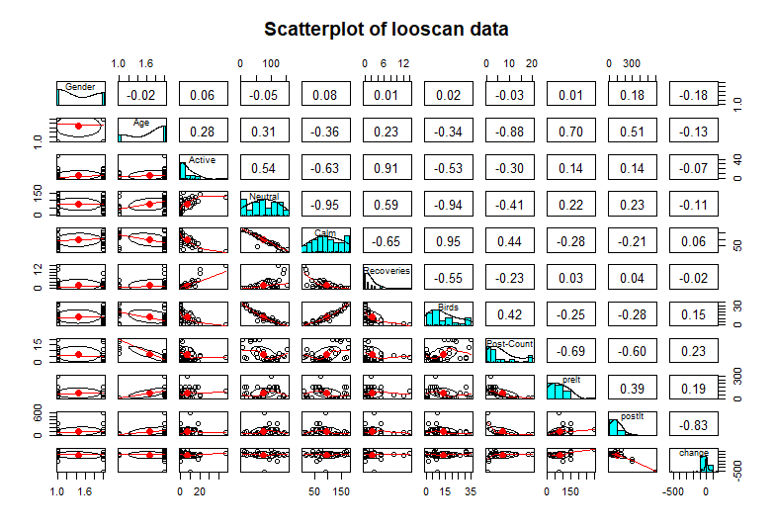

1. STEP 6 MODEL SUMMARY

> #PRINT THE SUMMARY

> summary(linearmod)

Call:

lm(formula = change ~ ., data = looscan)

Residuals:

Min 1Q Median 3Q Max

-2.438e-13 -1.846e-14 2.799e-15 3.845e-14 1.228e-13

Coefficients:

Estimate Std. Error t value Pr(>|t|)

(Intercept) 2.631e-13 1.925e-13 1.367e+00 0.1850

GenderM -3.516e-14 2.778e-14 -1.266e+00 0.2183

AgeK -1.138e-13 6.358e-14 -1.790e+00 0.0866 .

Active -5.199e-15 3.492e-15 -1.489e+00 0.1501

Neutral -9.542e-16 1.088e-15 -8.770e-01 0.3894

Calm -1.737e-15 1.282e-15 -1.356e+00 0.1884

Recoveries 1.533e-14 1.045e-14 1.467e+00 0.1560

Birds 7.218e-15 5.162e-15 1.398e+00 0.1754

`Post-Count` -9.247e-15 4.794e-15 -1.929e+00 0.0662 .

prelt 1.000e+00 3.148e-16 3.176e+15 <2e-16 ***

postlt -1.000e+00 1.566e-16 -6.384e+15 <2e-16 ***

---

Signif. codes: 0 ‘***’ 0.001 ‘**’ 0.01 ‘*’ 0.05 ‘.’ 0.1 ‘ ’ 1

Residual standard error: 7.556e-14 on 23 degrees of freedom

Multiple R-squared: 1, Adjusted R-squared: 1

F-statistic: 6.658e+30 on 10 and 23 DF, p-value: < 2.2e-16

Warning message:

In summary.lm(linearmod) :

essentially perfect fit: summary may be unreliable

1. STEP 11 SUMMARY OF MODEL

> ############PROBLEM ELEVEN#######

> #PRINT THE MODEL SUMMARY

> summary(looscannewmodel)

Call:

lm(formula = change ~ ., data = looscan)

Residuals:

Min 1Q Median 3Q Max

-2.021e-13 -2.583e-14 5.900e-15 3.010e-14 1.348e-13

Coefficients:

Estimate Std. Error t value Pr(>|t|)

(Intercept) 3.009e-13 1.908e-13 1.577e+00 0.1304

GenderM -3.571e-14 2.906e-14 -1.229e+00 0.2333

AgeK -1.326e-13 6.104e-14 -2.173e+00 0.0420 *

Active -8.208e-15 5.935e-15 -1.383e+00 0.1819

Neutral 2.334e-16 1.109e-15 2.100e-01 0.8355

Calm -9.883e-15 4.009e-15 -2.465e+00 0.0229 *

Recoveries 1.243e-14 1.105e-14 1.125e+00 0.2740

Birds 4.306e-14 1.648e-14 2.612e+00 0.0167 *

`Post-Count` -1.093e-14 4.617e-15 -2.367e+00 0.0281 *

prelt 1.000e+00 3.023e-16 3.308e+15 <2e-16 ***

postlt -1.000e+00 1.510e-16 -6.624e+15 <2e-16 ***

calm2 6.474e-17 3.216e-17 2.013e+00 0.0578 .

Active2 5.295e-17 1.015e-16 5.220e-01 0.6076

CB -3.098e-16 1.406e-16 -2.204e+00 0.0394 *

---

Signif. codes: 0 ‘***’ 0.001 ‘**’ 0.01 ‘*’ 0.05 ‘.’ 0.1 ‘ ’ 1

Residual standard error: 7.029e-14 on 20 degrees of freedom

Multiple R-squared: 1, Adjusted R-squared: 1

F-statistic: 5.92e+30 on 13 and 20 DF, p-value: < 2.2e-16

Warning message:

In summary.lm(looscannewmodel) :

essentially perfect fit: summary may be unreliable